# Synopsis on

# Absence Request and Vacation Scheduler Management System

Submitted in partial fulfillment of the requirements of the degree **BACHELOR OF ENGINEERING** IN **COMPUTER ENGINEERING**

By

**Rohan Shamkant Jawale(39) Aditi Anil Kembulkar (49)**

**Sarvesh Ankush Karande(47)**

Name of the Mentor

**Prof.**  **Pallavi Chandratre**



(Size 50 mm x 50 mm)

**Department of Computer Engineering**

Shivajirao S. Jondhale College of Engineering.

Dombivli (E)

(Affiliated to University of Mumbai)

(AY 2021-22)

# 

# CERTIFICATE

This is to certify that the Synopsis on Mini Project entitled **“Absence request and vacation scheduling management system”** is a bonafide work of **Rohan Shamkant Jawale (39),Aditi Anil Kembulkar (49), Sarvesh Ankush Karande (47)** submitted to the University of Mumbai in partial fulfillment of the requirement for the award of the degree of **“Bachelor of Engineering”** in **“Computer Engineering” .**

## Prof. Pallavi Chandratre

Mentor

## Dr. Uttara Gogate Dr. P.R. Rodge

Head of Department Principal

# Mini Project Approval

This Synopsis on Mini Project entitled “**Absence request and vacation scheduling management system”** by **Rohan Shamkant Jawale (39),Aditi Anil Kembulkar (49), Sarvesh Ankush Karande (47)** is approved for the degree of **Bachelor of Engineering** in **Computer Engineering.**

**Examiners**

**1………………………………………**

(Internal Examiner Name & Sign)

## 2…………………………………………

(External Examiner name & Sign)

Date: Place:

# Contents

## Abstract v

## Acknowledgments vi

## List of Figures vii

## Introduction 7

* 1. Introduction
  2. Motivation
  3. Problem Statement & Objectives
  4. Organization of the Report

1. **Literature Survey** **10**

**3 Existing System 11**

3.1 Survey of existing system

3.2 Limitations Of Existing System

## 4 Proposed System 12

4.1 Introduction

4.2 Project Implementation

4.3 Details of Hardware & Software

4.4 Flowchart

4.5 Results

4.6 Summary and Future work.

## Conclusion 22

## References 23

**ABSTRACT**

One of the major concerns of many organizations is problems about the absences of their employees. From multinational companies, to small start-ups and even educational institutes like schools and colleges, there is always a doubt that the employees are not monitored properly with regards to their absences. This creates confusion and uncertainty as to how many absences have been taken by each employee in the organization. Maintaining a manual record of the leave and vacation schedule is a tedious task and might be ineffective in huge companies with thousands of employees.

Therefore, our project aims at making absence requests an easier task for the employees, employer as well as the admin. It is also noticed that leave applications take a long time for approval. Hence, our project also targets to make this process time efficient as well as reduce the many drawbacks of the manual system.

We are developing a Python based flask application, using SQL for the database connectivity, that can be accessed throughout the organization or a specified group/Dept. This system can be used to automate the workflow of absence requests and their approvals. The periodic crediting of leave is also automated. Vacation scheduling is managed smoothly. There are features like notifications, first come first serve, easy approval of leave, cancellation of leave, periodic report generators etc. in our system.

**ACKNOWLEDGEMENT**

We would like to thank our college principal **Prof. P.R. Rodge** for providing lab facilities and permitting us to go on with our project

We also express our deepest thanks to our H.O.D. **Prof. Uttara Gogate** whose benevolent helps us making available the computer facilities to us for our project in our laboratory and making it true success. Without his kind and keen co-operation our project would have been stifled to standstill.

We would like to thank our project coordinator **Dr. Renuka Deshpande** for all the support we need from her for our project.

Lastly, we sincerely wish to thank our project guide **Prof. Pallavi Chandratre** for her encouraging and inspiring guidance helped us to make our project a success. Our project guide makes us endure with her expert guidance, kind advice and timely motivation which helped us to determine about our project .We would also like to thank our colleagues who helped us directly or indirectly during our project.

**LIST OF FIGURES**

1. Block diagram 12
2. Employee Flowchart 13
3. Authority Flowchart 14
4. Results 15

**1.INTRODUCTION**

**1.1 Fundamentals**

In the modern world, time is short so if there are many processes going on at the same time within a place there is a need for integration of all the processes, creation of a paperless environment which in return also ensures efficient task management.

The existing Absence management system is manual. It is a lengthy process and it is not optimized. The employee has to collect a leave form for a specific leave application and write the details then take it to relevant authorities for approval either to be granted, rejected or pending. The applicant is left in suspense because the response will not be received there and then after the application is made and it should be done three months before to the relevant authority.

We are creating Absence Request and Vacation Schedule Management based on python-flask to help solve this problem provide a system which manages the employee leave procedures. The employee fills and submits the leave application form through our website. The authority gets notified and hence can decide whether to grant, reject or keep the application form pending. We are trying to make a program to help employees get easy and fast absence requests without much suspense or worry.

**1.2 Objectives**

The main objectives of our project are:

1. Reduction of paper and manual work.
2. Time saving due to digital management in software which has very less manual intervention.
3. Easy and safe access of records.
4. Visibility of employee availability.
5. Clear communication and transparency of leaves of employees as every employee details are digitized.

Vacation scheduler is a one stop destination for staff to see all their leaves (employee personal leaves, public holidays as well as institutional holidays

**1.3 Scope**

Since there is a lot of hassle and time constraint in the manual method, we have tried to build this project to ease-out absence requests and scheduling for both employees and authority. This project is aimed at developing a web based Absence Request And Vacation Schedule Management Tool, which is of importance to either an organization or a college.

This is a Python based application that can be accessed throughout the organization or a specified group/Dept. This system can be used to automate the workflow of leave applications and their approvals. The periodic crediting of leave is also automated. Features like email notifications, cancellation of leave, automatic approval of leave, report generators etc are also incorporated in this web application.

**1.4 Organization of the report**

The report is organized as follows:

The introduction is given in Chapter 1. It describes the fundamental terms used in this project. This chapter also presents the outline of the objective of the report and the scope of the project. The chapter 2 describes the review of the systems that already exists. It describes the pros and cons of each technique. Chapter 3 presents the proposed work. It shows the implementation of the project. It describes the major approaches used in the project and also states the future work that can be done in the project.

**2.LITERATURE SURVEY**

|  |  |  |  |  |  |
| --- | --- | --- | --- | --- | --- |
| **SR.NO** | **YEAR** | **NAME OF RESEARCH PAPER** | **NAME OF THE AUTHORS** | **EXISTING SYSTEM** | **CONS** |
| 1. | 2018 | Employee Leave Management System(ISSN)2229-5518 | FreeStudentsProjects | Record of leaves of all the employess | Security Risk |
| 2. | 2011 | Leave Management System | Sai Ba Oo,Suparat Chainan | Leave application by employee and granting and rejection by authority | To calculate leave balance from a fix amount of annual leave was not available |

**3.EXISTING SYSTEMS**

**3.1 Survey of existing system**

Absence request Management system is the important system in administration department in all company. However, the management is different for each company. Some companies are still comfortable with the manual system and the others changed their system from manual to computerized to make the management more effective.

An Employee Management system was developed by the students of Babasaheb Gawde Institute of Technology. This system was created using concepts of Flask and Python, which focuses on employee’s record, types of leaves and number of leaves taken every month.

Referring to Newgen Technology Limited, leave time is a comprehensive and flexible leave management system enabling us to enter and manage leave requests according to company rules. They have created a software which is user friendly and the system saves time by eliminating paperwork, enhances employee satisfaction by speeding up the process and helps managers by ensuring compliance with company policies.

**3.2 Limitations of existing system**

3.1.1 Security risk

Manual record of data is quite risky. Possibility of data infringement and losing documents has emerged as a severe concern to manual information, a high level of security is required to withstand any interruption. There is a high chance of human errors in this system which makes it inefficient.

3.1.2 Can’t calculate the leave balance

The system was not able to calculate the pending leaves of the employee from the total number of leaves.

**4.PROPOSED SYSTEM**

**4.1 Introduction**

Absence management system was designed for an employee to apply for leave online. The application forms have been designed user friendly and fill in easily hence there will be less time consuming and also less expenses on stationery compared to the process of filling in the forms manually. The system will be developed in web bases completely and was required to use web technologies appropriately.

Below are certain objectives that should be gain in this project:

* To apply leave online (Employee)
* To receive leave application from staff online by auto generated email (Authority)
* To approve or reject staff leave application by auto generated email (Authority)
* To calculate leave balance from a fix amount of annual leave
* To record all leave information
* To view vacation scheduler

**4.2 Project Implementation**

This project includes two main modules.

1. Employee
2. Authority

1. Employee

Every employee has to first sign-up with his minimum details. These details include: name, email, employee ID and password.

After signing up, the employee can now login to his account using the correct credentials.

Once logged in, the employee is taken to the dashboard. The dashboard includes a quick review of the remaining leaves under each category.

The next feature is the Apply for leave, here the employee fills his/her form to get leave sanctioned.

Then there is leave history, which gives the employee his/her all past leave records for reference.

Edit profile is where all the personal information is stored and can be edited to make any changes.

Vacation scheduler redirects to a calendar where everyone in the organization can view company related holidays/ public holidays.

1. Authority

Authority is the head and the one who sanctions leaves application of employees. The authority first logs in the system using correct credentials.

Once logged in, the authority also gets to see the dashboard. The authority dashboard shows all the pending requests sent by the employees in the organization. Other features at the authority side include all employee information.

Emergency leave is a new feature where the employee, in case of a mishap or accident can inform the authority, and then get a leave on an emergency basis.

Vacation scheduler is to be updated regularly by the authority, for the employees and other staff to refer.

**4.3 Details of hardware and software**

1. Hardware:

* Processor: i3 or above
* HDD: 256 GB
* RAM: 2 GB

1. Software:

* Operating System: Windows 10
* Software IDE: Visual Studio Code

**4.4 FLOWCHART**

4.4.1 Block diagram

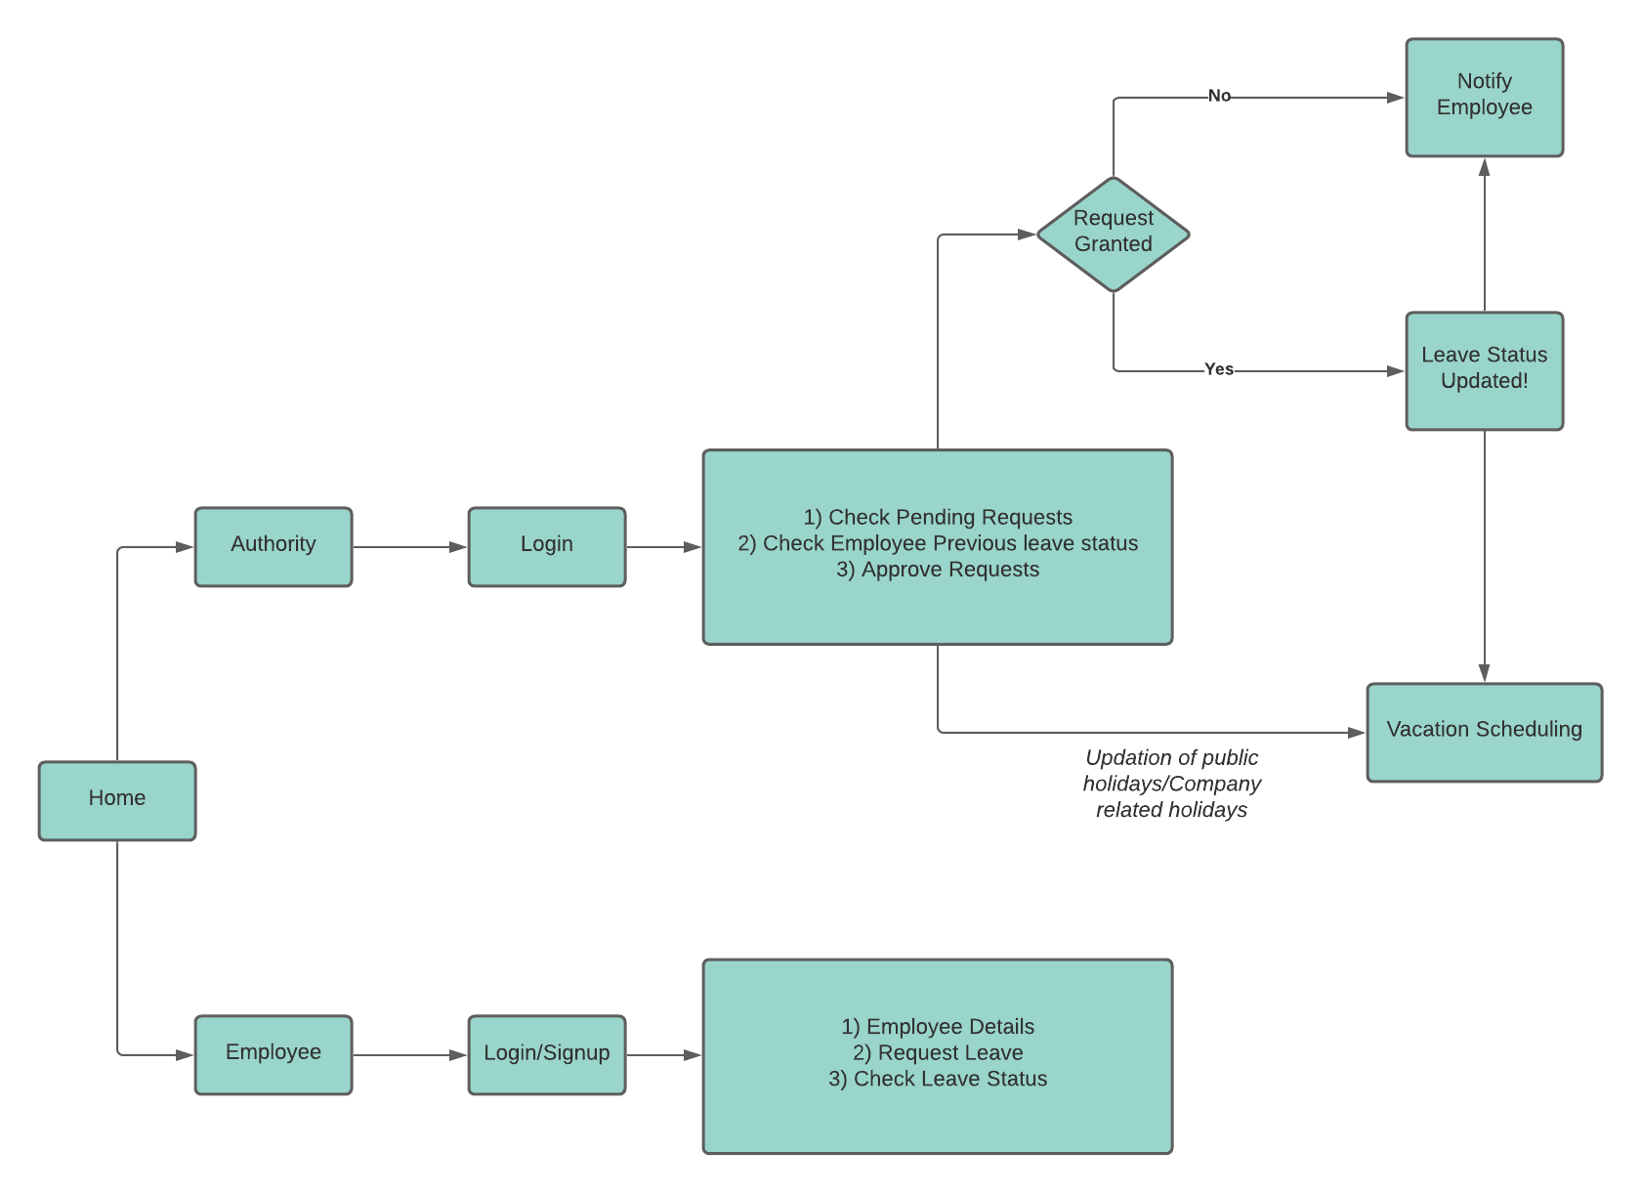

4.4.2 FLOW CHARTS

1. EMPLOYEE

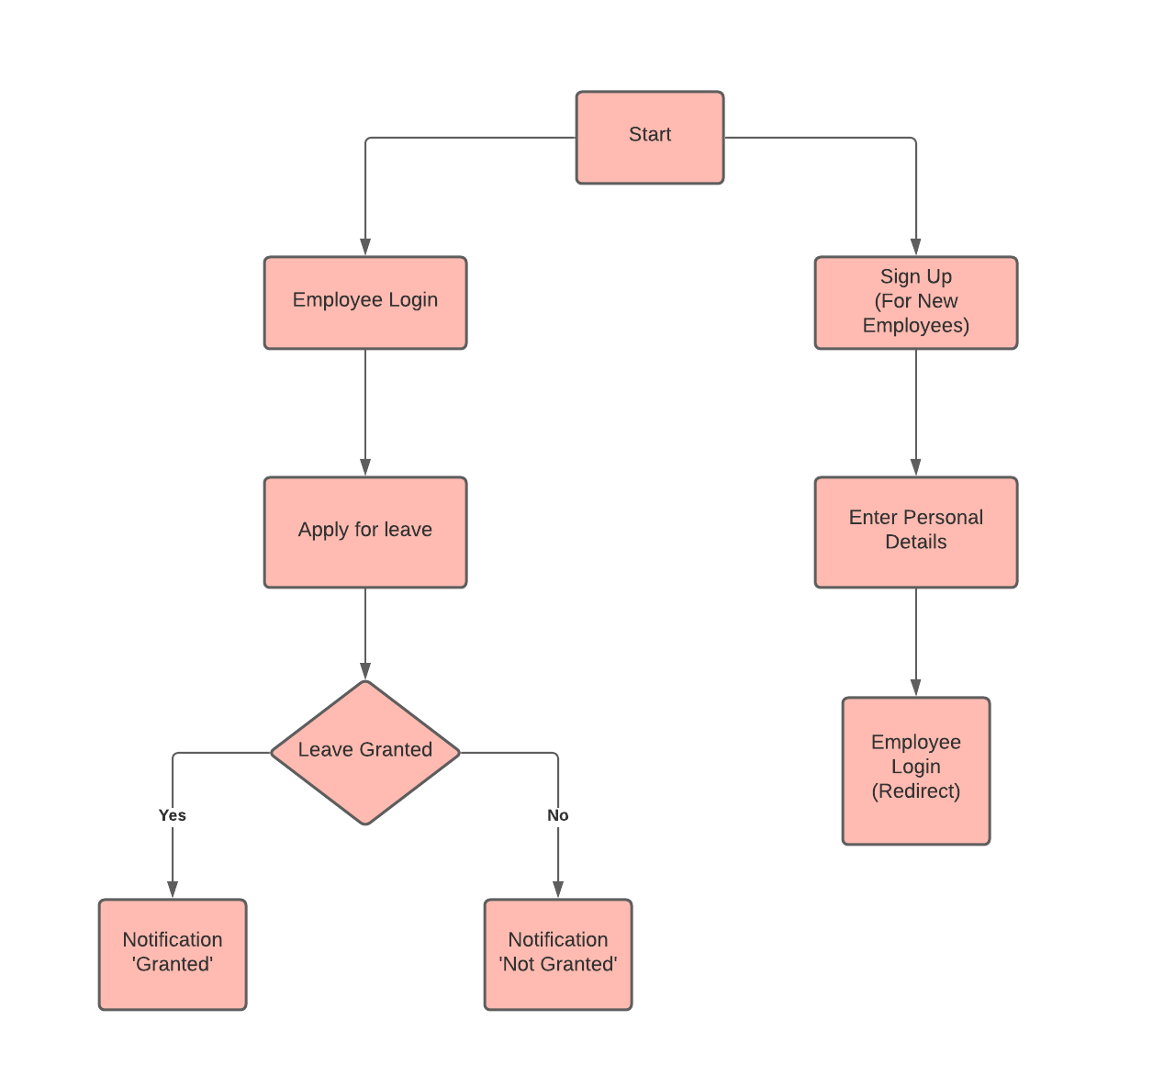

1. AUTHORITY

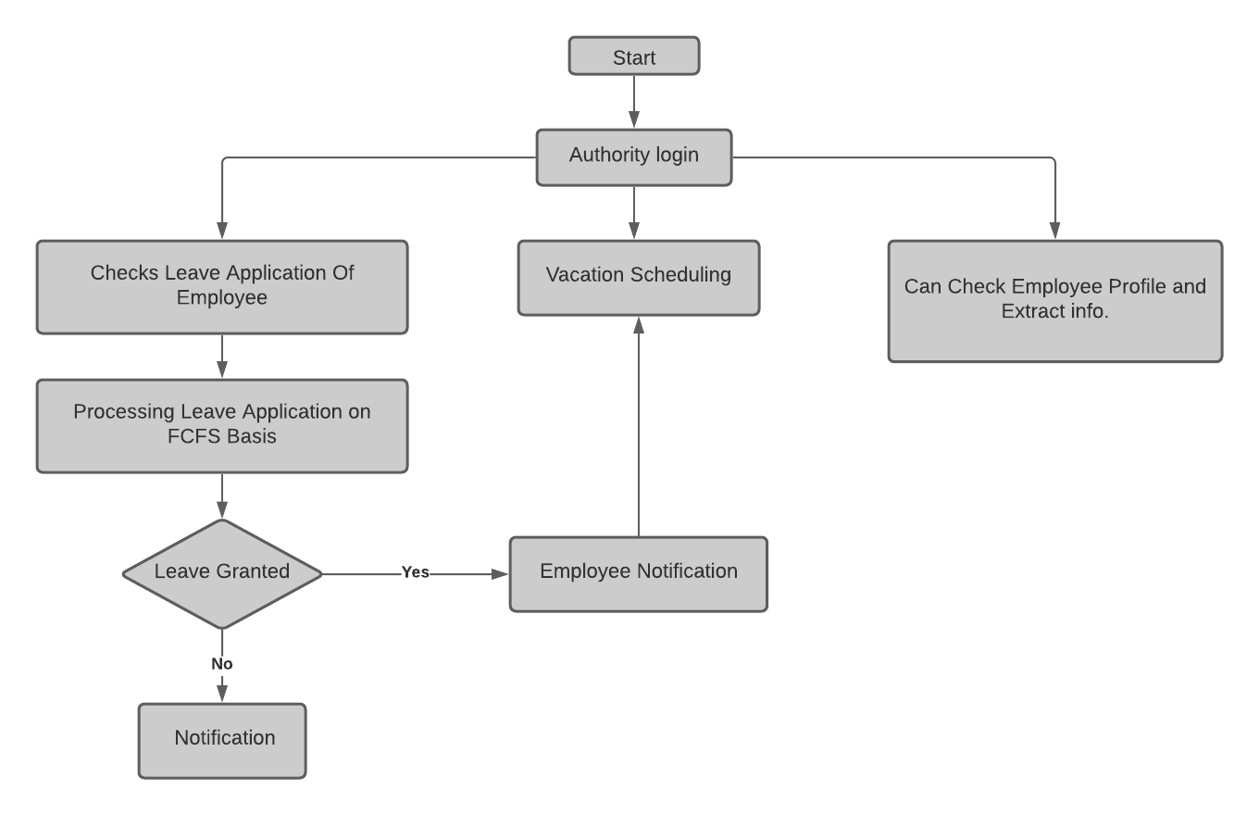

**4.5 Results**

1. Employee Sign up page:

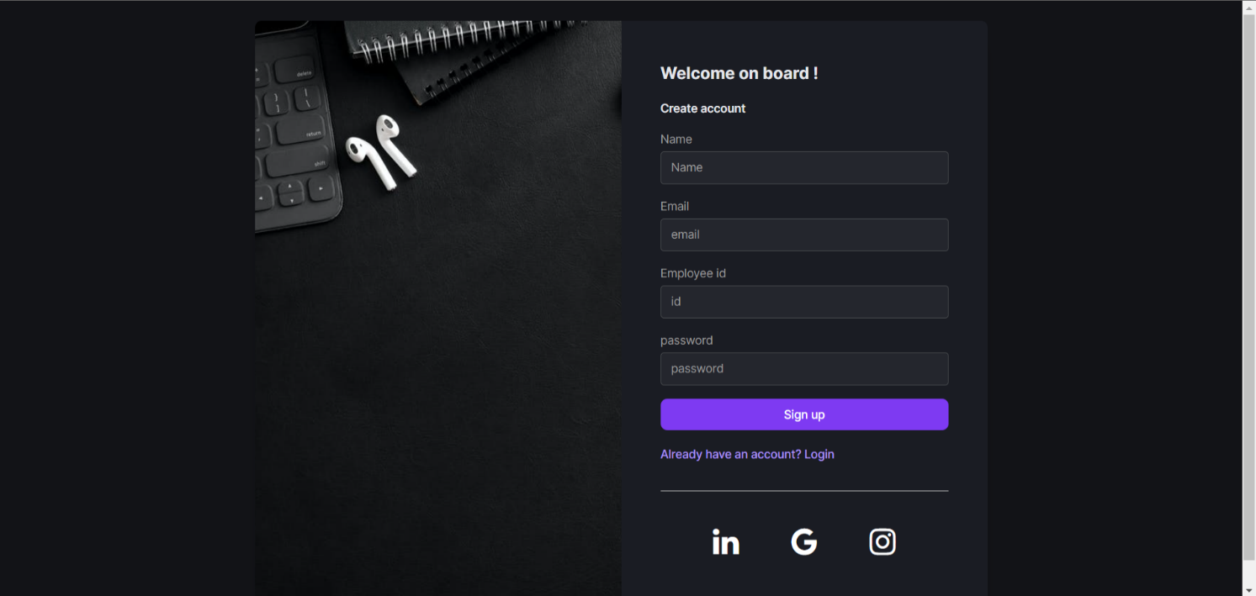

1. Employee Login page:

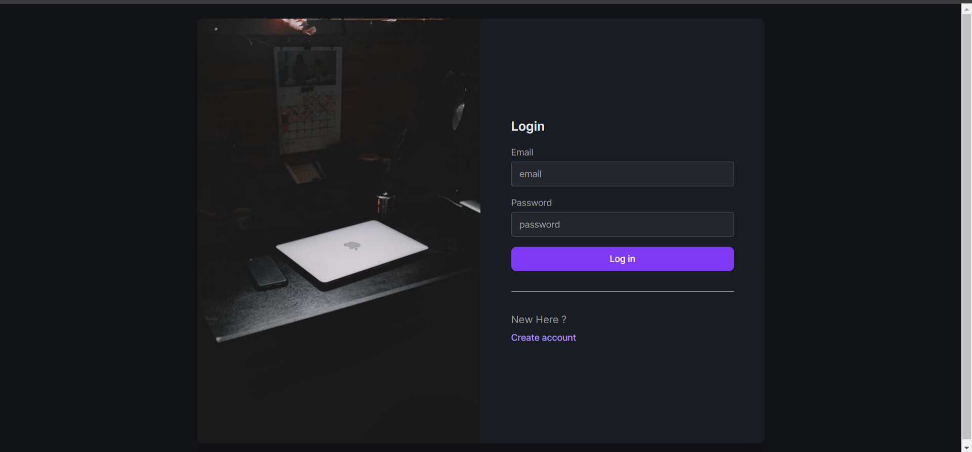

1. Employee Dashboard page:

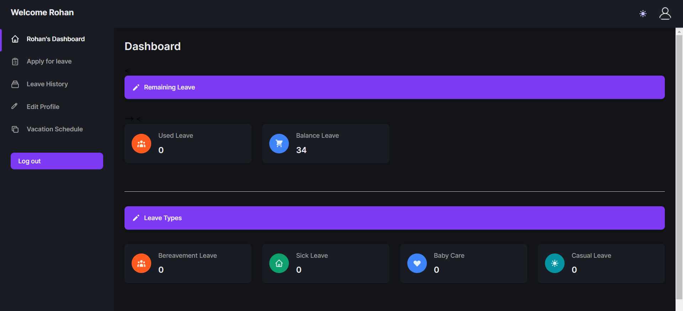

1. Authority Login page:

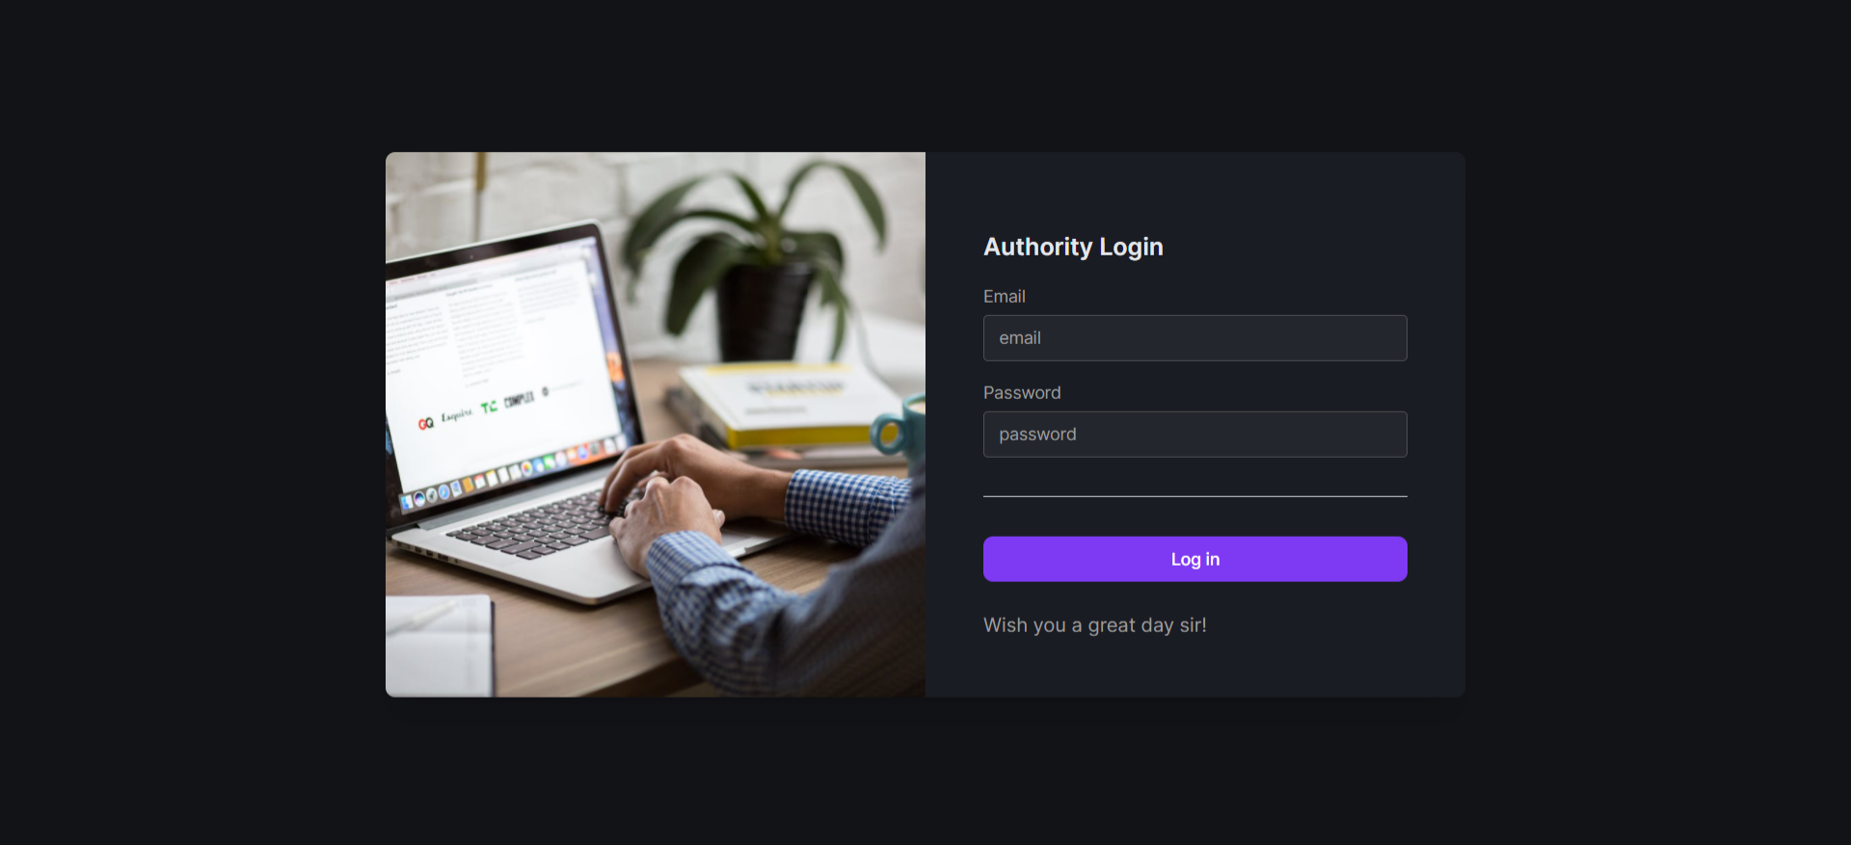

1. Authority Dashboard

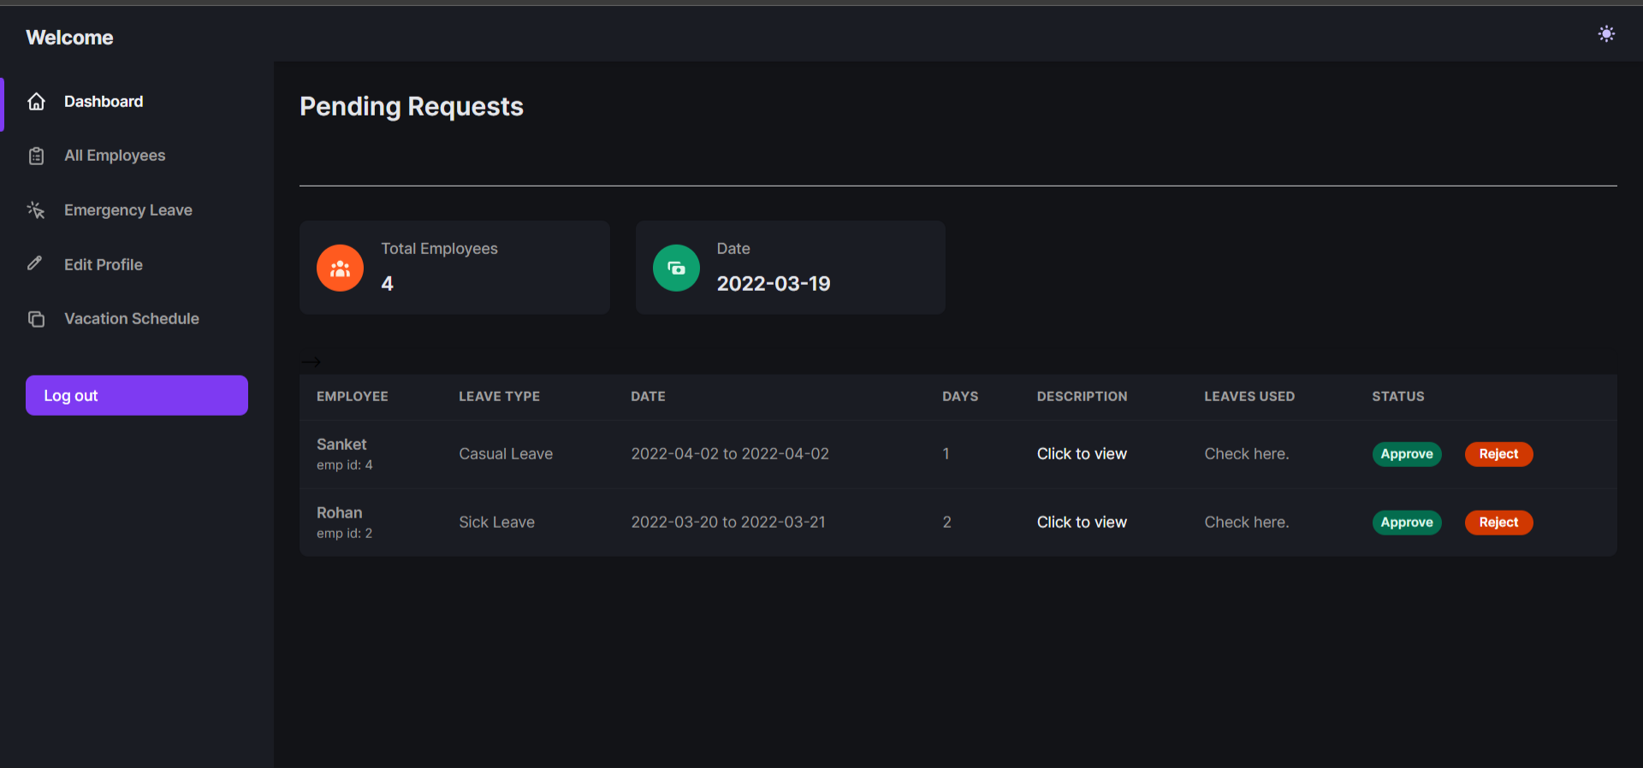

1. Vacation Scheduler:

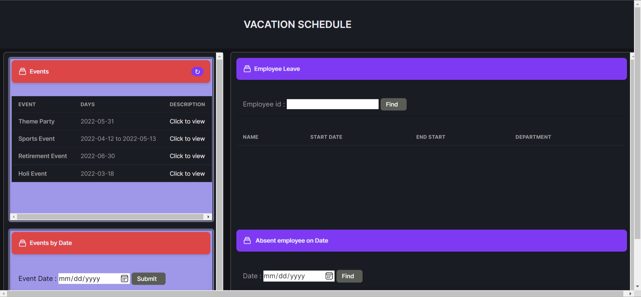

**4.6 Summary and Future Scope:**

The very essence of this project lies in its ease, accessibility and durability.

Adding more fields in the project could help it to manage other implementations and not just stay limited to leave applications and vacation scheduling. There is hope to develop a system that approves and rejects employee leave applications without the interference of authorities, for faster and easier approvals. A feature to calculate salary of the employees after taking a specific amount of unpaid leaves would help them to maintain records. Vacation scheduling calendar could have incorporated leaves of all employees present in the company, so that each stuff gets to see the availability of a particular employee.

Absence request and Vacation scheduling management system is a multi-professional topic. Considering the recent outbreak of coronavirus which led to worldwide pandemic, we saw the increase in the number of companies and organizations shifting their setup from a manual to fully online mode. Hence this project has a paramount importance in currently as well as in the near future.

**CONCLUSION**

Absence Request and Vacation Schedule Management system is very useful for any institution using it, to maintain the leave records of employees. This system will not only maintain the leave applications of the staff, it will also maintain the previous leave records of the staff.

The higher authority may accept or reject the applications requested by the employee. Thus, this system maintains the excess amount of work done by the institution to maintain the leaves.

The system also approaches to reduce the formalities and delay by authority members for the approval of leave. The vacation scheduler helps all the staff to see their leaves, public holidays and institution holidays all at one place itself.

This project will be developed using html, CSS, python, Flask, and MySQL which fully meets the objective of the system which it has been developed.

**REFERENCES**

1.Employee Leave Management System, “International Journal of Scientific & Engineering Research Volume 9”, (ISSN 2229-5518), February 2018.

2.Leave Management System, “Rashtrasant Tukadoji Maharaj Nagpur University,”, [IEEE](http://ieeexplore.ieee.org/xpl/mostRecentIssue.jsp?punumber=6767436)

3.<https://www.w3schools.com/php/>

4.<https://developer.mozilla.org/en-US/docs/Learn/Getting_started_with_the_web/JavaScript_basics>

5.<https://www.moneycontrol.com/personal-finance/tools/gratuity-calculator.html>